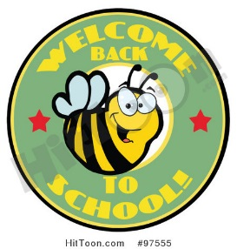
Ms. Bitely’s Second Grade Class

Home of the Bitely BUGS

2017-2018
Welcome to second grade! I hope you are ready to begin another fun and
challenging year! Please supply your child with the following school supplies for the first
day of school. (Please remove all extra packaging before sending in the supplies.) Please do not label any items with your child’s name, unless asked to label item below, as we will do this our first day together.
* BUGS’ Supply List*
Personal Supplies [Please LABEL THESE supplies with student’s first and last name.]
- 1 Adams Agenda
- 5 single subject, spiral bound notebooks labeled with: Student Name AND Math, Reading, Writing, Social Studies/Science, Extra Work
- 2 two pocket durable poly (plastic) folders, any color, NO PRONGS!
  - >Label one folder with Student’s Name and Unfinished Work and the other folder with Student’s Name and Writing
- 1 pencil bag labeled with student’s name
  - 1 package crayons> Put in pencil bag
  - 1 pack sharpened colored pencils> Put in pencil bag
        - 2 LARGE pink erasers> Put in pencil bag
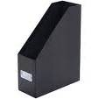
      - 1 clipboard> Labeled with student’s name
      - 1 jumbo magazine file plastic or wire —labeled with student’s name
Shared Supplies [These items will be collected and shared with the class as needed]
- 2 packs of 12-24 pre-sharpened pencils, not decorative and NO MECHANICAL!
      - 1 package of glue sticks
      - 2 packs of wide-ruled loose leaf paper
      - 1 package baby-wipes
      - 1 inches & centimeters ruler
- 1 package dry-erase (whiteboard) markers

* Ms. Bitely’s Wish List*

*Playground equipment [Balls, sidewalk chalk, jump ropes, etc.

*Individually packaged snacks for students’ snack time

*Small prizes for Prize Box (Dollar Tree, McDonald’s, etc)

*Dice!

*Colored copy paper

*Colored Cardstock

*Classroom games for indoor recess days

*Any extras from the supply list!
Thank
you!
